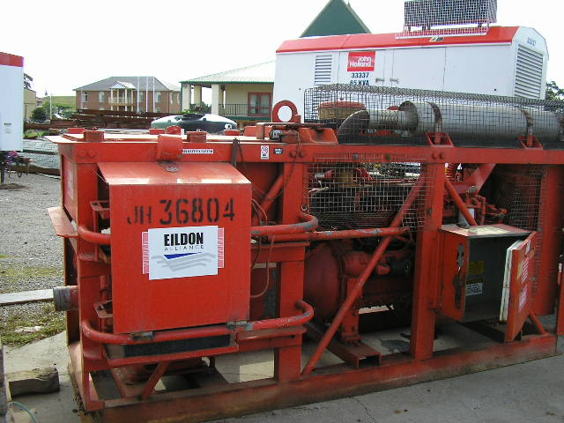 | Hazard Information Sheet
  Equipment: | Pumps
 | Equip Type: | Pumps - Petrol/Diesel
 | Generic Description or  Specific Make / Model: | Pumps
 | Type: | Petrol/Diesel
 | Other Details

Operator Requirements: | Operators must be trained and competent to use this equipment safely.
Purpose For Which This Equip Is Designed: | For pumping clean or dirty water, or water containing sand, mud or solids in suspension. Not to be used for pumping flammable or corrosive fluids.

Hazards & Risks:
Control Measures:
Entanglement:  Becoming entangled with moving parts e.g. if operator is cleaning impeller (centrifugal pumps) or if hands/limbs are in vicinity of push rods/cams (diaphragm pumps). | (i) Shut pump down if access is necessary to moving parts.  (ii) Keep hands/limbs and/or clothing clear of moving parts when pump is working.
High Temperature or Fire:  Refuelling: When refuelling, sparks, flames, hot engine can ignite fuel. | Before refuelling, operator to shut down engine and turn off all electrical switches. When refuelling, ensure that there are no naked flames in the area. DO NOT SMOKE. Avoid spilling fuel and collect any fuel run off.
Noise:  Exposure to noise. | Personnel working with or in the vicinity of this equipment to wear suitable hearing protection.
Manual Handling:  Body strain if equip requires manual lifting. | Ask for assistance to lift or carry machine. Eg crane

Disclaimer: In fulfilment of its statutory obligations, (ARS) & John Holland has taken what it considers to be all reasonable precautions and exercised due diligence to ensure that it has provided all relevant information on the safe use of the plant. However, except as required by law and only to the extent so required, (ARS) & John Holland does not make any representation, warranty or undertaking, express or implied, as to, or accept any responsibility or liability for, the accuracy or completeness of, or any errors in or omissions from, this Hazard Information Sheet. Except as required by law and only to the extent so required, neither (ARS) & John Holland nor any of its respective directors, officers, agents, or employees shall in any way be liable directly or indirectly to any person or body for any loss or damages, costs or expenses whatever arising out of or in connection with the information contained in this Hazard Information Sheet. | Date: 19/06/06
Equipment: | Pumps  Petrol/Diesel

Hazards & Risks: | Control Measures:
Suffocation:  Machine could be sited in a confined space and cause asphyxiation. | Operator instruction — site machine in well ventilated area.
Crushing:  Possible movement of equip if not sited on level surface e.g. vibration could cause pump to move and slide down an embankment or | Site pump on level surface, chock if appropriate.  fall into reservoir.

Disclaimer: In fulfilment of its statutory obligations, (ARS) & John Holland has taken what it considers to be all reasonable precautions and exercised due diligence to ensure that it has provided all relevant information on the safe use of the plant. However, except as required by law and only to the extent so required, (ARS) & John Holland does not make any representation, warranty or undertaking, express or implied, as to, or accept any responsibility or liability for, the accuracy or completeness of, or any errors in or omissions from, this Hazard Information Sheet. Except as required by law and only to the extent so required, neither (ARS) & John Holland nor any of its respective directors, officers, agents, or employees shall in any way be liable directly or indirectly to any person or body for any loss or damages, costs or expenses whatever arising out of or in connection with the information contained in this Hazard Information Sheet. | Date: 19/06/06

